**Hand movement Project**

**Joseph Tran**

**11204688**

Neural Networks and Fuzzy Logic

Table of Contents

1. Introduction 3

2. Background of the project 4

3. System Design 5

4. Design implementation 5

5. Results and discussion 6

6. Conclusion and future directions 6

References 7

Appendices 8

# Introduction

* What is the context in which this is applied?
* What is the goals that we hope to achieve?

In a world where technology is evolving, it is important to begin to develop strategies to assist technology with adapting to the various constraints that humans have. This includes developing interfaces or platforms where communication between each other is strengthened or improved.

The overall goal of this project is to provide a strategy to recognise hand gestures and control music through the interaction of the hand and its respective movement.

The context arises when your hands are unable to perform adequately due to:

* Hands being unclean
* One of the hands are busy

As such our project aims to provide a test platform that can be further built upon and utilised using a neural network.

Our goals for this project are:

1. Decide on 4 hand gestures to recognise
2. Capture 4 hand gestures in terms of x, y, z coordinates across a period of 200 milliseconds
3. Train a neural network to recognise the 4 hand gestures
4. Control music through the computer
5. Combine the music control with the neural network and have the music operated via hand gestures
6. Demonstrate real time control of music

# Background of the project

# System Design

* How is it made?

# Design implementation

# Results and discussion

## Attempt 1

* Weights made of 1 or 0 often fail to recognise anything, hence some randomness is needed
* A single neuron cannot recognise more than one thing

The neural network was a single neuron and attempting to train it to learn all 4 hand gestures became almost impossible as the output could only produce either a 1 or a -1 at best.

It was also discovered very early on, that if you had weights of 0, the feedforward process would not work very well. As the weights never changed. Weights with just 1s worked fine, though arrived at the desired weight a lot longer than just random weights.

It was discovered from this attempt that the output could only be composed of -1 or 1s (via the sigmoid function)

## Attempt 2

Observation upon running 8000 steps, with each cycle being 400.

The following is the errors of running through 400 training inputs of which there are 100 recordings of each gesture (4 gestures). This is depicted by the blue line or the cycleErrors of the training of the neural network.

Whilst the red line is the validationErrors is 400 separate training inputs, also of which contains 100 recordings per gesture.

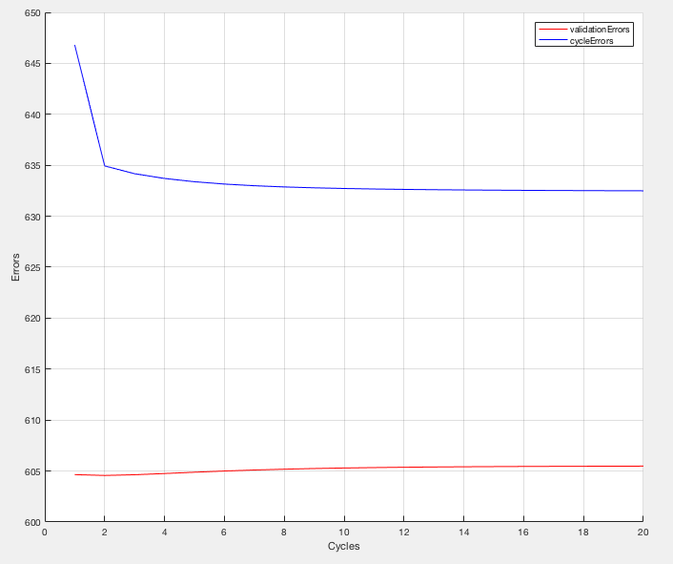

It is observed at approximately the second cycle, that the errors of the validation inputs start to increase, suggesting that the training has sufficiently learnt all that it can from just 2 cycles.

# Conclusion and future directions

# References

# Appendices